Three Winding Transformer Test System

W. H. Kersting
February 2014

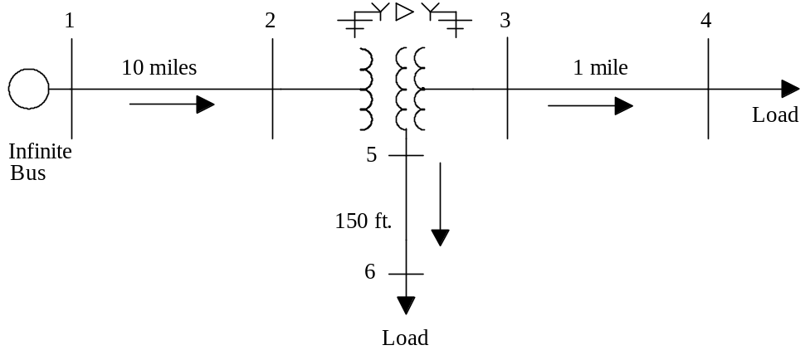

Figure 1 – Test System

Transformer Ratings:

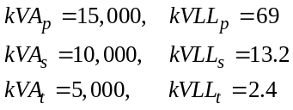

Per-Unit transfer impedances based upon 15,000 kVA and rated line-to-line voltages

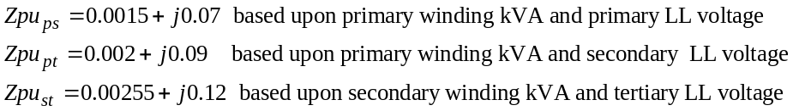 per-unit

Transmission line 1-2:

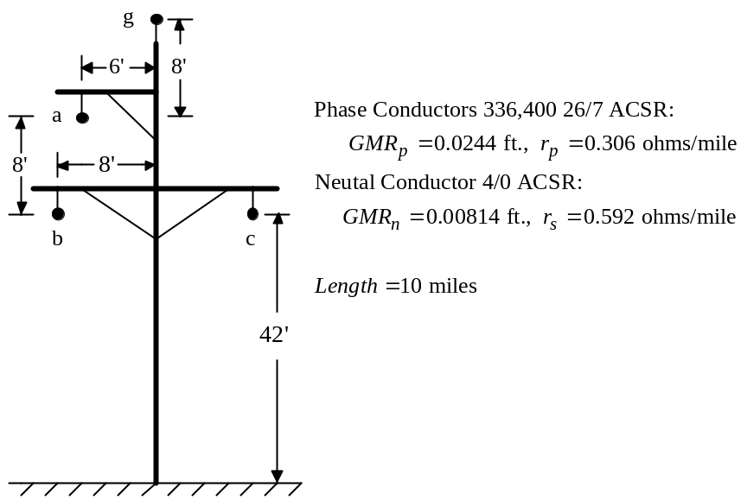

Distribution line 3-4:

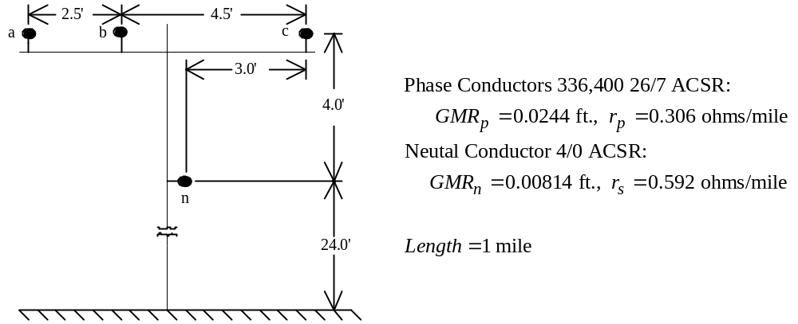

Distribution line 5-6:

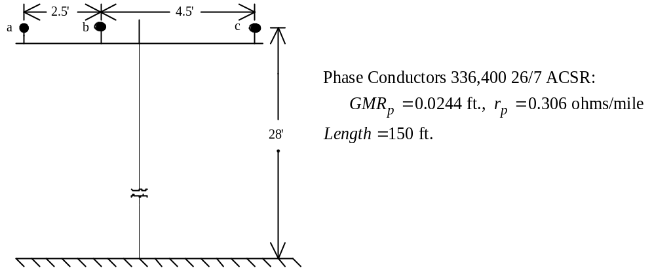
Bus 4 Constant PQ Load:

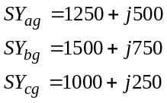 kW+jkvar

Bus 6 Constant Z Load:

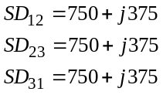 kW+jkvar

Infinite Bus: Balanced line-to-line 69 kV

Three-phase transformer circuit:
